# Lab1 Day1 Assignment 1 Case Study

1. In the given problem, the two cases of the hierarchy is the student and the faculty.
2. The two common behavior are:
3. All of them can take elective course.
4. All of them can view marks or attendance
5. The users are: Student (graduate,Postgraduate)

Faculty(Lecturer(Full-time,Part-time),HOD)

Admin

1. Student and Course details are needed to print the report.

# Lab1 Day1 Assignment 2 Case Study

1. Studentid, studentType,studentAddress

Studentid can be hidden. stuentType can be exposed.

1. 2 method is enough. One for Graduate and one for post graduate.It might have same name and signature but different parameter..Yes. the functionality in these method is same.
2. Two functions. One for hostelite and one for dayscholar.
3. A-encapculation ,method overloading and Inheritance

# Lab1 Day1 Assignment3 Case Study

1.state

2.state

3. identity

4.encapsulation

5.object

6.behavior

7.inheritance

8.abstraction

9.polymorphism

# Case Study Day4 Assignment 3 Inheritence

Scenario1:

Yes there will be inheritance. The class diagram is as shown below:

# 

Scenario 2:

Yes there will be inheritance. The class diagram is as shown below:

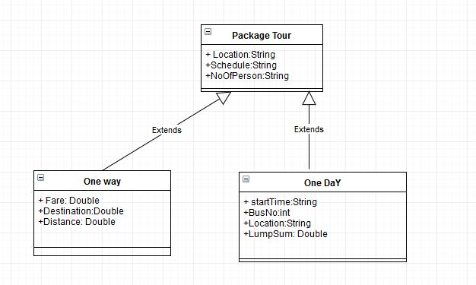

# Day5 Assignment 4UML Diagram

